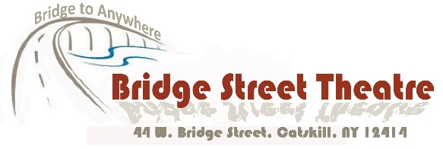
For Immediate Release
August 13 – August 25, 2019
Bridge Street Theatre presents
“…And Every Tale Condemns Me For a Villain”
Two Solo Shows in Rotating Rep on Characters from Shakespeare
THRICE TO MINE (world premiere) created and performed by Roxanne Fay
SHYLOCK by Gareth Armstrong, performed by Steven Patterson
August 15 – 25, 2019
Bridge Street Theatre Mainstage
44 West Bridge Street, Catskill, NY
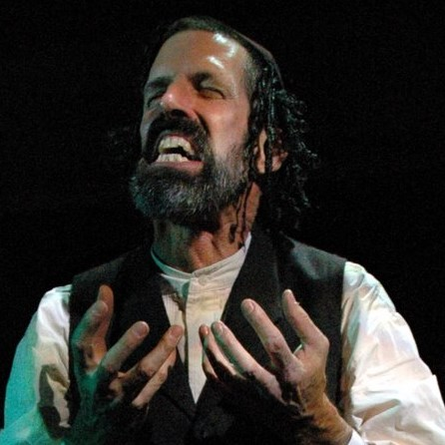
Steven Patterson in Gareth Armstrong’s “Shylock”
Gareth Armstrong’s “Shylock” At Catskill’s Bridge Street Theatre August 15th-25th
Tummler
Etymology:
Circa 1930, from Yiddish טומלער‎ (tumler).
1. An employee – usually male – of a Borscht Belt resort charged with the duty of entertaining guests throughout the day by providing any number of services, from comedian to master of ceremonies.
2. A lively, mischievous man.
One of the things actor Steven Patterson discovered during his first run with Gareth Armstrong’s play “Shylock” at the Orlando Shakespeare Theatre back in 2007 was a way of getting inside Tubal, its main character, by viewing him as a Catskills tummler.
“Gareth was determined to make our production in Florida (the first he’d authorized in English by anyone other than himself) unique – not just a carbon copy of the one he’d toured all over the world for a decade. He tailored the script in ways that made it more friendly to an American audience, as opposed to his original British one. He forced me (gently) to find my own way even when I begged him to ‘PLEASE just let me know how you solved this’. However, the major way we found to make the show more distinctly ‘American’ was to draw on the bottomless wealth of immigrant Jewish humor that’s so much a part of our theatrical heritage here in the U.S. Jacob Adler’s Yiddish Theatre. The great Jewish comics of the vaudeville circuit and radio (the Marx Brothers, Jack Benny, Fanny Brice, George Burns, etc). And especially the Borscht Belt jokes of the vintage Catskills resorts. All gave me a real ‘in’ into this character. This guy is trying hard to please, trying to make sure everybody’s having the best possible time. And when approaching a play as full of potential landmines as ‘The Merchant of Venice’, that tack proved to be ideal. Now that my husband John (who’s directing this production) and I have been residents here in the Catskills for more than a decade, it feels as though some of that history has seeped into my bones and I only hope I’m at least living up to the second definition of a tummler – a lively, mischievous man! Can’t wait to share this unique, funny, and tragic vision of Jewish identity with audiences here in the Hudson Valley. ‘They tried to kill us, we survived, let’s eat!’”
Patterson brings his performance in “Shylock” to the stage of Catskill’s adventurous Bridge Street Theatre from August 15-25, in rotating repertory with “Thrice To Mine”, Roxanne Fay’s one-woman show that tells the fascinating story of the woman on whom Shakespeare based the character of Lady Macbeth. Generally perceived as villainous in the plays in which they appear, these two characters receive far more probing and sympathetic scrutiny in both these bracing theatrical inquiries. Were these two “villains” really villains?
“Shylock” and “Thrice To Mine” will be performed together in Catskill under the title “…And Every Tale Condemns Me For a Villain”. Recommended for audiences ages 13+, the plays alternate performances on Thursdays and Fridays at 7:30pm and Saturdays and Sundays at 3:00 and 7:00pm from August 15 – 25, 2019 at Bridge Street Theatre, 44 West Bridge Street, in Catskill, NY, just a block and a half west of Main Street across the Uncle Sam Bridge, which spans Catskill Creek.
You can view the shows individually or in “one fell swoop” at Saturday and Sunday Marathons (with a break in between). General Admission is $25, Students 21 and under are only $10. Discounted advance tickets are available online at thrice.brownpapertickets.com and shylock.brownpapertickets.com or by calling 800-838-3006. Tickets will also be sold at the door one half hour prior to each performance on a space available basis. “Pay What You Will” performances take place on Thursday evening August 15, Friday evening August 16, and at both the matinee and evening performances of the Sunday Marathon on August 18 (“Pay What You Will” tickets are available only at the door one half hour prior to these performances). For more details, visit the theatre online at BridgeStreetTheatre.org.
Events at Bridge Street Theatre are supported in part by the New York State Council on the Arts with the support of Governor Andrew M. Cuomo and the New York State Legislature and by Public Funds from the Greene County Legislature through the Cultural Fund administered in Greene County by the Greene County Council on the Arts.
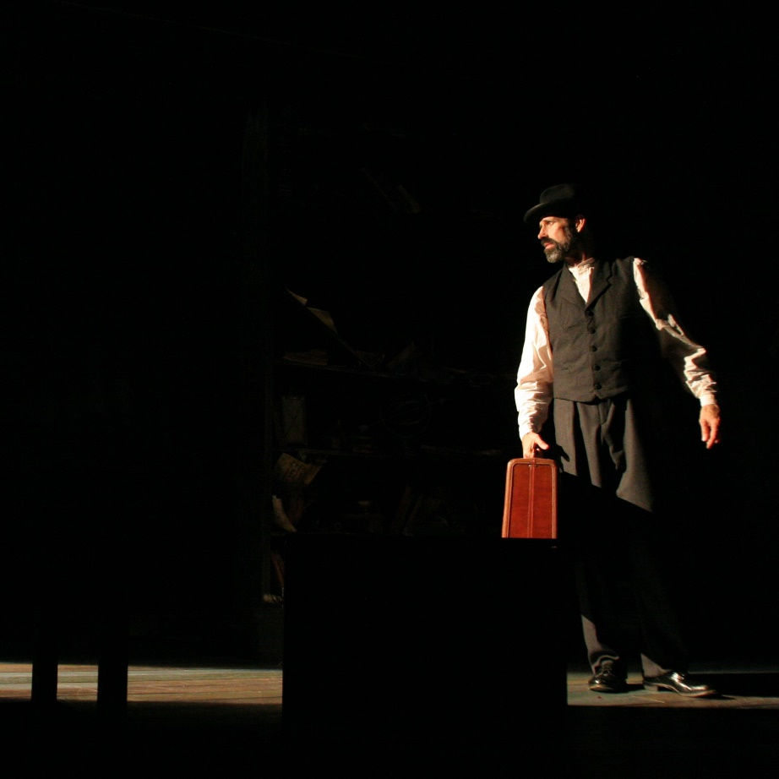
Steven Patterson in Gareth Armstrong’s “Shylock
Performance Calendar:
Bridge Street Theatre presents
“…And Every Tale Condemns Me For a Villain”
Two Solo Shows in Rotating Rep on Characters from Shakespeare
THRICE TO MINE (world premiere) created and performed by Roxanne Fay
SHYLOCK by Gareth Armstrong, performed by Steven Patterson
August 15 – 25, 2019
Bridge Street Theatre Mainstage
44 West Bridge Street, Catskill, NY
THRICE TO MINE – Thursday August 15 @ 7:30pm (“Pay What You Will”)
SHYLOCK – Friday August 16 @ 7:30pm (“Pay What You Will”)
SHYLOCK – Saturday August 17 @ 3:00pm
THRICE TO MINE – Saturday August 17 @ 7:00pm
THRICE TO MINE – Sunday August 18 @ 3:00pm (“Pay What You Will”)
SHYLOCK – Sunday August 18 @ 7:00pm (“Pay What You Will”)
SHYLOCK – Thursday August 22 @ 7:30pm
THRICE TO MINE – Friday August 23 @ 7:30pm
THRICE TO MINE – Saturday August 24 @ 3:00pm
SHYLOCK – Saturday August 24 @ 7:00pm
SHYLOCK – Sunday August 25 @ 3:00pm (Closing performance)
THRICE TO MINE – Sunday August 25 @ 7:00pm (Closing performance)
Tickets:
Advance tickets available at http://thrice.brownpapertickets.com and http://shylock.brownpapertickets.com, or by calling 800-838-3006.
General Admission $22, $10 for students ages 21 and under
Tickets can also be purchased at the door prior to each performance (on a space available basis) for $25, $10 for Students ages 21 & under.
“Pay What You Will” tickets are available only on the day of performance and go on sale at the door one half hour before curtain time.

