For Immediate Release
July 26 – August 25, 2019
Bridge Street Theatre presents
“…And Every Tale Condemns Me For a Villain”
Two Solo Shows in Rotating Rep on Characters from Shakespeare

THRICE TO MINE (world premiere) created and performed by Roxanne Fay
SHYLOCK by Gareth Armstrong, performed by Steven Patterson
August 15 – 25, 2019
Bridge Street Theatre Mainstage
44 West Bridge Street, Catskill, NY
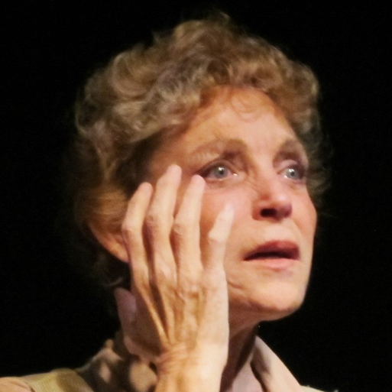
Roxanne Fay’s THRICE TO MINE
Photo: John Sowle
“…And Every Tale Condemns Me For a Villain” Coming to Catskill’s Bridge Street Theatre

“My conscience hath a thousand several tongues,
And every tongue brings in a several tale,
And every tale condemns me for a villain.”
Richard III – V,3
A pair of fascinating solo shows that strive to reclaim two controversial Shakespeare characters hit the stage at Catskill’s adventurous Bridge Street Theatre from August 15 – 25. Roxanne Fay’s “Thrice to Mine” and Gareth Armstrong’s “Shylock” will be performed in rotating rep on the BST Mainstage under the umbrella title “…And Every Tale Condemns Me For a Villain”.

Generally perceived as villainous in the plays in which they appear – “Macbeth” and “The Merchant of Venice”, respectively – Lady Macbeth and Shylock receive far more probing and sympathetic scrutiny in each of these bracing theatrical inquiries. To quote yet another, more unambiguously malevolent Shakespeare character: “And what’s he then that says I play the villain?” Were these two “villains” actually – villains?

Princess. Wife. Mother. Witch. Murderer. Queen. Roxanne Fay’s “Thrice To Mine” opens a new door into the heart of Gruoch ingen Boite, the woman on whom Shakespeare modeled the character we know as Lady Macbeth. Based on the historical figure of Gruoch herself and of the times in which she lived, “Thrice To Mine” presents a woman denied power by society and gender politics who learns from the other women in her life how to fight back and to control and maintain her personal power. Through magic and lore, the story of her extraordinary life becomes a rich, fulfilling, and deliciously dark experience. Created during a residency at Hawthornden Castle in Scotland, where playwright/performer Roxanne Fay was a 2016 Hawthornden Writing Fellow, “Thrice To Mine” is being presented here in Catskill in its world premiere engagement.

Neither apologia nor indictment, Gareth Armstrong’s “Shylock” is, instead, a celebration of the infinite possibilities inherent in Shakespeare’s problematic play “The Merchant of Venice”. Through its main character, Tubal (the only other Jewish man apart from Shylock in the whole of Shakespeare), the play takes a tummler’s-eye view of the entire history of anti-Semitism (right up to the present), of the character of Shylock himself, and of the wildly varying ways in which the role has been interpreted through the years. It also incorporates large swaths of Shakespeare’s original dialogue, holding it up to the light and revealing startling and unexpected facets and nuances. Actor Steven Patterson originally performed “Shylock” in 2007 at the Orlando Shakespeare Theatre, in a critically-acclaimed production directed by the playwright himself (the first time Armstrong had allowed the play to be performed in English by anyone else), and, co-incidentally, stage managed by Roxanne Fay! After viewing this funny, thought-provoking, and haunting piece, you’ll never be able to look at “The Merchant of Venice” in the same way again.
“…And Every Tale Condemns Me For a Villain” is recommended for audiences ages 13+ and alternates performances on Thursdays and Fridays at 7:30pm and Saturdays and Sundays at 3:00 and 7:00pm from August 15 – 25, 2019 at Bridge Street Theatre, 44 West Bridge Street, in Catskill, NY, just a block and a half west of Main Street across the Uncle Sam Bridge, which spans Catskill Creek. You can view the shows individually or in “one fell swoop” at Saturday and Sunday Marathons (with a break in between).
General Admission is $25, Students 21 and under are only $10. Discounted advance tickets are available online at thrice.brownpapertickets.com and shylock.brownpapertickets.com or by calling 800-838-3006. Tickets will also be sold at the door one half hour prior to each performance on a space available basis. “Pay What You Will” performances will be held on Thursday evening August 15, Friday evening August 16, and at both the matinee and evening performances of the Sunday Marathon on August 18 (“Pay What You Will” tickets are available only at the door one half hour prior to these performances). For more details, visit the theatre online at BridgeStreetTheatre.org.
Events at Bridge Street Theatre are supported in part by the New York State Council on the Arts with the support of Governor Andrew M. Cuomo and the New York State Legislature and by Public Funds from the Greene County Legislature through the Cultural Fund administered in Greene County by the Greene County Council on the Arts.
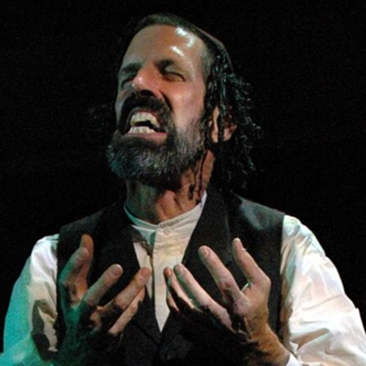
Steven Patterson as Marlowe’s Barabbas in SHYLOCK
Photo: Tony Firriolo

Performance Calendar:
Bridge Street Theatre presents
“…And Every Tale Condemns Me For a Villain”
Two Solo Shows in Rotating Rep on Characters from Shakespeare

THRICE TO MINE (world premiere) created and performed by Roxanne Fay
SHYLOCK by Gareth Armstrong, performed by Steven Patterson
August 15 – 25, 2019
Bridge Street Theatre Mainstage
44 West Bridge Street, Catskill, NY
THRICE TO MINE – Thursday August 15 @ 7:30pm (“Pay What You Will”)
SHYLOCK – Friday August 16 @ 7:30pm (“Pay What You Will”)
SHYLOCK – Saturday August 17 @ 3:00pm
THRICE TO MINE – Saturday August 17 @ 7:00pm
THRICE TO MINE – Sunday August 18 @ 3:00pm (“Pay What You Will”)
SHYLOCK – Sunday August 18 @ 7:00pm (“Pay What You Will”)
SHYLOCK - Thursday August 22 @ 7:30pm
THRICE TO MINE – Friday August 23 @ 7:30pm
THRICE TO MINE – Saturday August 24 @ 3:00pm
SHYLOCK – Saturday August 24 @ 7:00pm
SHYLOCK – Sunday August 25 @ 3:00pm (Closing performance)
THRICE TO MINE – Sunday August 25 @ 7:00pm (Closing performance)
Tickets:
Advance tickets available at http://thrice.brownpapertickets.com and http://shylock.brownpapertickets.com, or by calling 800-838-3006
General Admission $22, $10 for students ages 21 and under
Tickets can also be purchased at the door prior to each performance (on a space available basis) for $25, $10 for Students ages 21 & under.
“Pay What You Will” tickets are available only on the day of performance and go on sale at the door one half hour before curtain time.
Further Information:
To contact Bridge Street Theatre directly, email contact@bridgest.org or call their offices at 518-943-3894. For more information on Bridge Street Theatre visit BridgeSt.org.
If you do not wish to receive future press releases from Bridge Street Theatre, please reply to this email with your request.

Bios:

Gareth Armstrong (Playwright, SHYLOCK) is a Welsh actor, director, teacher and writer. On stage he has played leading roles in most of the UK's regional theatres including Birmingham Rep, Nottingham Playhouse, and the Bristol Old Vic where parts ranged from Mamet to Molière. He has specialized in Shakespearean theatre where roles have included Romeo, Richard III, Oberon, Macbeth, Shylock and Prospero. As a member of the Royal Shakespeare Company he worked in Stratford and London and has performed in the West End in plays by Noël Coward, Tom Stoppard, Agatha Christie and most recently in Yes, Prime Minister. He played at Shakespeare's Globe in 2008, 2010, and 2011. He has also toured to over fifty countries and all over the United States with his own one-man show Shylock, in which Shakespeare's principal Jewish character is seen from the viewpoint of Tubal, the Bard's only other male Jewish character and Shylock's only friend in the original play. The play has won awards in New Zealand, Canada, Spain and Germany and been translated into Catalan, Spanish, Italian, French and Russian as well being performed on Dutch television and Romanian radio. On radio Armstrong has played three recurring roles in The Archers on Radio 4, including Sean Myerson, the publican of the Cat and Fiddle and the serial's first regular gay character.

Roxanne Fay (Playwright/Performer, THRICE TO MINE). As an actor, Roxanne has been lauded for her work in a wide range of roles. Most recently, Roxanne received acclaim for her portrayals of Miriam (Apples In Winter), Prospero (The Tempest), Paige (HIR), Leni Riefenstahl (Leni), Beatrice (The Effect of Gamma Rays on Man-iin-the-Moon Marigolds). and Nurse Ratched (One Flew Over The Cuckoo's Nest). In Florida, she has been named Best Actress/Best of The Bay several times for her work in The Normal Heart, Cabaret, Side Man, and The Year Of Magical Thinking. Roxanne has enjoyed ten years as a storyteller in Disney World/EPCOT Center's Holidays Around The World. As a writer, she was named a 2016 Hawthornden Writing Fellow, in residence at Hawthornden Castle, Scotland, where she created Trice To Mine. She was the first recipient of the Norton Dream grant (Theatre Tampa Bay, 2013), funding the creation of her novel, Upon This Rock:The Magdalene Speaks which she also adapted for the stage. Her collected plays, Home Fires Burning, were chosen for presentation in the 2014 United Solo Festival, New York City.Her play, Dream Child: The Trial Of Alice In Wonderland, premiered at the Dali Museum (FL) prior to its run at Bridge Street Theatre (NY) in 2016. Roxanne is also Producing Artistic Director of Circle In The Water, LLC, a theatrical company, presenting new and established works.

Steven Patterson (Performer, SHYLOCK) has performed in NYC both Off- and Off-Off-Broadway, as well as regionally with theaters such as South Coast Repertory, Capital Repertory Theatre, TheatreWorks/Silicon Valley, freeFall Theatre, Kaliyuga Arts, Lexington Conservatory Theatre, Chenango River Theatre, Centenary Stage Company, and the Orlando, Oregon, Colorado, Pennsylvania, Utah, Tennessee, Richmond, and Lake Tahoe Shakespeare Festivals. A few of his favorite roles have been Austin Wiggin in The Shaggs: Philosophy of the World, Jake Sturdy in Kill Me Now, Lear in King Lear, David in Poor Super Man, Judi Boswell in How to Pray, The Creature in Frankenstein: The Modern Prometheus, Zach in A Chorus Line, and Rob in King of the Crystal Palace. He also created, performed, and toured internationally for four years with Beauty, a solo show inspired by the life and works of Jean Genet. He currently resides in Catskill, NY, and serves as an Associate Artist at Bridge Street Theatre, where he has appeared in The Epic of Gilgamesh, The Killing & The Love Death, Grinder’s Stand, A Life in a Day: Lucky Lindy, Frankenstein: The Modern Prometheus, Holiday Memories, How to Pray, Frankie & Johnny in the Clair de Lune, The Revenge of the Space Pandas, There Is A Happiness That Morning Is, and The Shaggs: Philosophy of the World, and directed George M. Cohan’s The Tavern, The Effect of Gamma Rays on Man-in-the-Moon Marigolds, and The Revenge of the Space Pandas.

